**Year 8 Biology End of Topic Test**

**/54**

**Name: ______________________________________**

Multiple Choice Answer Sheet

1. A B C D 16. A B C D

2. A B C D 17. A B C D

3. A B C D 18. A B C D

4. A B C D 19. A B C D

5. A B C D 20. A B C D

6. A B C D 21. A B C D

7. A B C D 22. A B C D

8. A B C D 23. A B C D

9. A B C D 24. A B C D

10. A B C D 25. A B C D

11. A B C D 26. A B C D

12. A B C D 27. A B C D

13. A B C D

14. A B C D

15. A B C D

**Multiple Choice**

**1.** The simplest units of life that we could call alive are:

a. atoms

b. cells

c. molecules

d. proteins

**2.** The main purpose of respiration in organisms is:

a. to produce carbon dioxide

b. so that plants can breathe

c. to remove oxygen from the atmosphere

d. to produce energy

**3.** reproduction involving two parents is:

a. asexual

b. sexual

c. simple fission

d. simple asexual

**4.** Which of the following lists contain only examples of mechanical digestion?

a. Chewing in the mouth and the churning by stomach muscles.

b. Chewing in the mouth, protease break down of proteins.

c. Churning by the stomach muscles and protease break down of proteins.

d. Protease break down of proteins is the only example.

**5.** Which of these statements about the equation below is **INCORRECT**:

[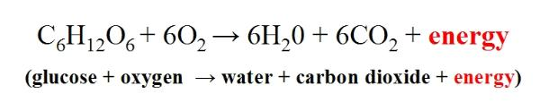](http://www.google.com.au/url?sa=i&rct=j&q=&esrc=s&frm=1&source=images&cd=&cad=rja&docid=zISSTtDQqk4lVM&tbnid=CiDE1YE4C7BFfM:&ved=0CAUQjRw&url=http://cronodon.com/BioTech/Respiration.html&ei=BjzIUaLLLIrakAWNjIGQBQ&bvm=bv.48293060,d.dGI&psig=AFQjCNHWDWbN0w1PaKgMe-_x2xQtW0lWaQ&ust=1372163451373414)

1. The glucose comes from the digestive system
2. This is the equation for cellular respiration
3. The oxygen enters the body through the heart
4. The carbon dioxide is removed from the body in the alveolus

**6.** Spermatozoa (sperm) mature in a structure called the:

a. testes.

b. ovaries.

c. Vas Deferens.

d. epididymis.

[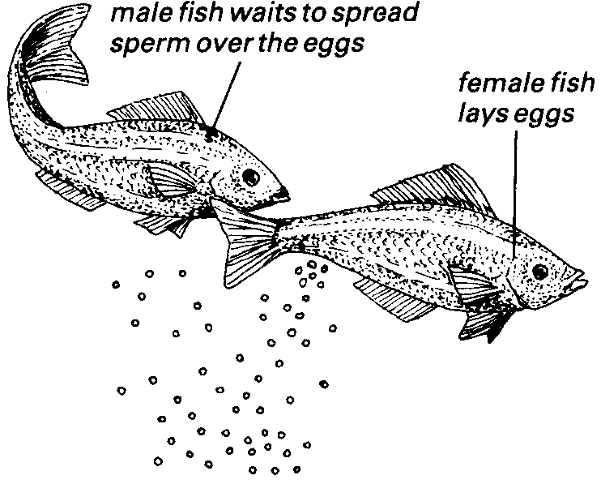](http://www.google.com.au/url?sa=i&rct=j&q=&esrc=s&frm=1&source=images&cd=&cad=rja&docid=IBJUx3qiVPRbgM&tbnid=WyWRach9E2cQVM:&ved=0CAUQjRw&url=http://dj003.k12.sd.us/SCHOOL%20NOTES/bk2chpt%207.htm&ei=gT3IUav5K8-DkgXh0YCoCQ&psig=AFQjCNHO7Pr-G9opaqDK7hUw2BkZlQbjLw&ust=1372163813138663)**7.** Which of the following words describes the reproduction of fish as shown in the diagram

a. asexual

b. sexual

c. simple fission

d. simple asexual

**8.** Ovulation occurs is:

1. The degeneration of an egg after 2 or 3 days.
2. the release of a mature egg from the ovary.
3. the fusing of an egg and sperm.
4. the development of a spermatazoa in the ovary.

**9.** In which of the following does the exchange of oxygen between the blood and body cells occur?

1. Arteries.
2. Platelets.
3. Veins.
4. Capillaries.

**10.** Which of the following is NOT correct about breathing in?

1. The diaphragm contracts and moves down.
2. The diaphragm contracts and moves up.
3. The rib cage moves up and out.
4. The spongy tissue of the lungs expands.

**11.** The alveoli are which of the following?

1. Hairlike structures lining the trachea and bronchus.
2. The muscle between the ribs.
3. The tube leading from the mouth to the lungs.
4. Small air sacs in the lungs, needed for gas exchange.

**12.** Which of the following shows the correct order of structures that air would pass through as it was breathed in?

1. Alveoli, mouth, bronchioles and bronchus.
2. Diaphragm, bronchioles, trachea and mouth.
3. Mouth, trachea, bronchus, bronchioles and alveoli.
4. Mouth, trachea, bronchioles, bronchus and diaphragm.

**13.** Which of the following is the reason that the heart is classified as an organ?

1. It is a group of different tissues working together to do a particular function.
2. It is made of a group of cells working together to do a particular function.
3. It has a function that is vital for life.
4. It is part of a larger system.

**14.** Where does respiration happen?

1. In all living cells.
2. In the lungs.
3. In the heart.
4. In the blood.

**15.** The intercostal muscles are found:

1. Under the lungs.
2. Between the ribs.
3. In the heart.
4. Lining body organs.

Look at the diagram below and use it to answer questions 16, 17, 18 and 19

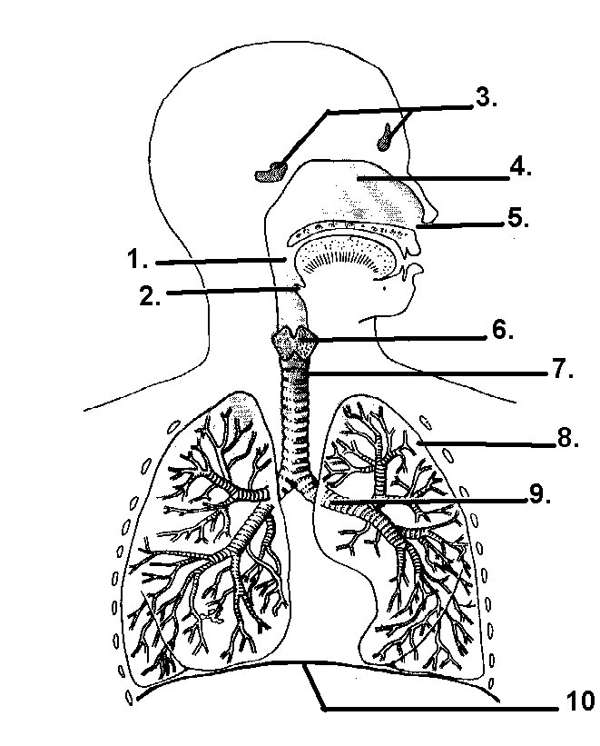

**16.** In the diagram structure 10 is the:

1. Trachea.
2. Intercostals muscles.
3. Pleural membrane.
4. diaphragm.

**17.** The function of structure 6 is:

1. To stop the trachea from collapsing when the neck is bent or a person breathes in.
2. Allows a person to speak.
3. Warms the air before it enters the lungs.
4. Prevents food entering the lungs.

**18.** The function of structure 2 is:

a. To stop the trachea from collapsing when the neck is bent or a person breathes in.

b. Allows a person to speak.

c. Warms the air before it enters the lungs.

d. Prevents food entering the lungs.

**19.** Which of the following statements is correct?

a. Structure 9 is the trachea

b. Structure 7 is the trachea

c. Structure 9 is a Bronchus

d. Structure 9 is a Bronchiole

**20.** The backflow of blood between the ventricles and the atria is prevented by which of the following?

1. Cardiac muscles.
2. Tendons.
3. Valves.
4. Veins.

**21.** Which one of the following statements is **true?**

1. The left ventricle wall is thicker than the right ventricle wall because it must pump blood a greater distance.
2. The right ventricle wall is thicker than the left ventricle wall because it must pump the blood a greater distance.
3. The left ventricle wall is thicker than the right ventricle wall as it must withstand greater blood pressure.
4. The right ventricle wall is thicker than the left ventricle wall as it must withstand greater blood pressure.

**22.** Bile is stored in the:

1. gall bladder.
2. stomach.
3. large intestine.
4. small intestine.

**23.** The pancreas can be described as which of the following?

1. An organ that produces enzymes.
2. A site of chemical digestion.
3. A site of mechanical digestion.
4. An organ of excretion.

**24.** Absorption of water in the digestive system occurs in which of the following organs?

1. stomach.
2. large intestine.
3. liver.
4. anus.

Use the following diagram to answer questions 25, 26 and 27.

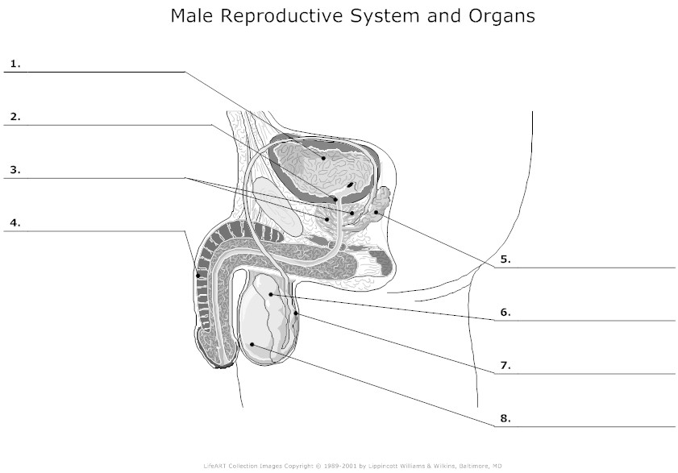

**25.** After spermatozoa (sperm) are produced they travel through various parts until they leave the body at ejaculation. In order, what are the first three structures in this journey?

1. 2, 3, 4.
2. 8, 3,4.
3. 8, 6, 7.
4. 2, 8, 7.

**26.** In the diagram above which number represents the erectile tissue?

1. 1.
2. 2.
3. 3.
4. 4.

**27**. The reason the testes (number8) are located hanging outside the main body is

a. They could not be seen if they were inside the body

b. They would get too warm if they were inside the body

c. There is no room for them inside the body

d. So the sperm can reach the penis more quickly.

**SHORT ANSWER SECTION**

**1** Why is it important for the small intestine to have a large surface area?

1 mark

2. Complete the table below.

|  |  |
| --- | --- |
| Cell | Function |
| Red blood cell |  |
| White blood cell |  |

2marks

**3.** Do **NOT** label this diagram, just use it to fill in the table below

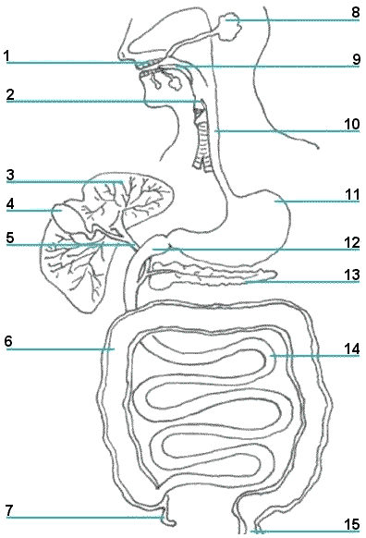

|  |  |  |
| --- | --- | --- |
| **Number** | **Name of structure** | **Function** |
| **8** |  |  |
| **11** |  |  |

(4marks)

**4.** Do NOT label this diagram. Just use it to answer the questions below

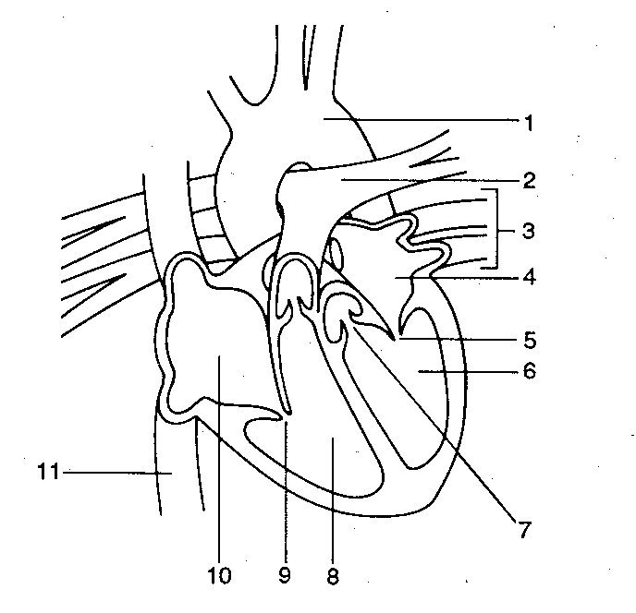

Use **red arrows to show the direction of oxygenated blood** through the heart and **blue arrows to show the flow of deoxygenated blood** through the heart. If you use different colours please use a key to show what the colours mean. 2 marks

|  |  |  |
| --- | --- | --- |
| **Number** | **Name** | **Function** |
|  |  | Takes deoxygenated blood to the lungs |
|  | Aorta |  |
| 8 |  | No need to fill in this box |
|  |  | Brings deoxygenated blood to the heart from the lower body |

6 marks

**5.** Complete the following sentences. 5 marks

The blood vessels that bring blood back to the heart are called ______________. The blood vessels that take oxygenated blood away from the heart are called ________________. These second type of blood vessel have thick elastic walls to withstand _______________.

When someone does physical exercise their pulse rate increases. This helps to supply blood rich in the gas _______________ to the body cells. The body cells use this gas to burn glucose to gain ___________.

**6** Do NOT label this diagram. Just use it to answer the questions below

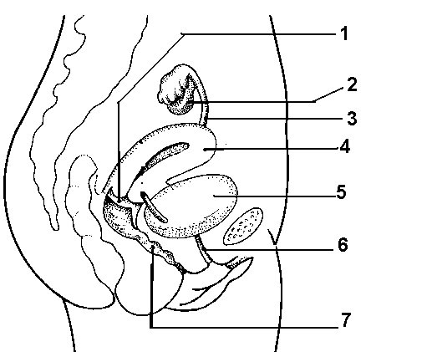

|  |  |  |
| --- | --- | --- |
| **Number** | **Name** | **Function** |
|  |  | Place where the baby will develop |
|  | Ovary |  |
| 3 |  |  |
|  | Vagina | Becomes the birth canal |

7 marks

**Year 8 Biology End of Topic Test**

**/60**

**Name: ANSWER KEY**

Multiple Choice Answer Sheet

1. A B C D 16. A B C D

2. A B C D 17. A B C D

3. A B C D 18. A B C D

4. A B C D 19. A B C D

5. A B C D 20. A B C D

6. A B C D 21. A B C D

7. A B C D 22. A B C D

8. A B C D 23. A B C D

9. A B C D 24. A B C D

10. A B C D 25. A B C D

11. A B C D 26. A B C D

12. A B C D 27. A B C D

13. A B C D

14. A B C D

15. A B C D

**ANSWERS SHORT ANSWER SECTION**

**1. A** Label the diagram

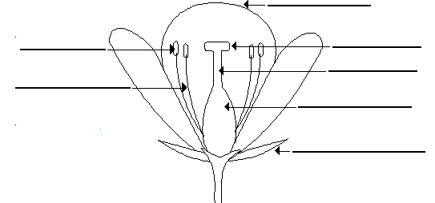

From top right

Petal Stigma Style Ovule Sepal Filament Anther

3 marks

**B.** Now shade in the male parts one colour and the female parts another colour using a key to show which is which. Red=Female Blue=Male 2 marks

**2 A** The small intestine increases its surface area in two ways. What are those two ways?

Villi : Folds 2 marks

**B** Why is it important for the small intestine to have a large surface area?

Large Surface area= Large absorption of nutrients into blood 1 mark

**3.** Do **NOT** label this diagram, just use it to fill in the table below



|  |  |  |
| --- | --- | --- |
| **Number** | **Name of structure** | **Function** |
| **8** | Salivary gland | Add chemical salivary amylase to Break down starch |
| **10** | Oesophagus | Pushes food to stomach in contractions |

1 each = (4marks)

**4.** Do NOT label this diagram. Just use it to answer the questions below



Use **red arrows to show the direction of oxygenated blood** through the heart and **blue arrows to show the flow of deoxygenated blood** through the heart. If you use different colours please use a key to show what the colours mean. 2

|  |  |  |
| --- | --- | --- |
| **Number** | **Name** | **Function** |
| 2 | Pulmonary Artery | Takes deoxygenated blood to the lungs |
| 1 | Aorta | Takes oxygenated blood to all of the body |
| 8 | Right ventricle | No need to fill in this box |
| 11 | Inferior Vena Cava | Brings deoxygenated blood to the heart from the lower body |

6 marks

**5.** Complete the following sentences. 5 marks

The blood vessels that bring blood back to the heart are called _Veins___. Some of these types of blood vessels have __Valves__ that stop the back flow of blood. The blood vessels that take oxygenated blood away from the heart are called _Arteries . These second type of blood vessel have thick elastic walls to withstand __Pressure____.

When someone does physical exercise their pulse rate increases. This helps to supply blood rich in the gas _Oxygen_____ to the body cells. The body cells use this gas to burn glucose to

**6** Do NOT label this diagram. Just use it to answer the questions below



|  |  |  |
| --- | --- | --- |
| **Number** | **Name** | **Function** |
| 4 | Uterus | Place where the baby will develop |
| 2 | Ovary | Maturation and release of egg cell |
| 3 | Fallopian Tube | Site of fertilisation …. Egg/zygotes moved to uterus |
| 7 | Vagina | Becomes the birth canal |

7 marks

Part of the digestive system is visible in the above diagram. Identify and circle the digestive system. Arrow above 1 mark